Foxglove Digitalis purpurea
- Foxglove leaves, flowers and seeds contain the drugs digoxin and digitoxin which increase the strength of the failing heart and slow the heart when it is beating rapidly and irregularly in a condition called atrial fibrillation.

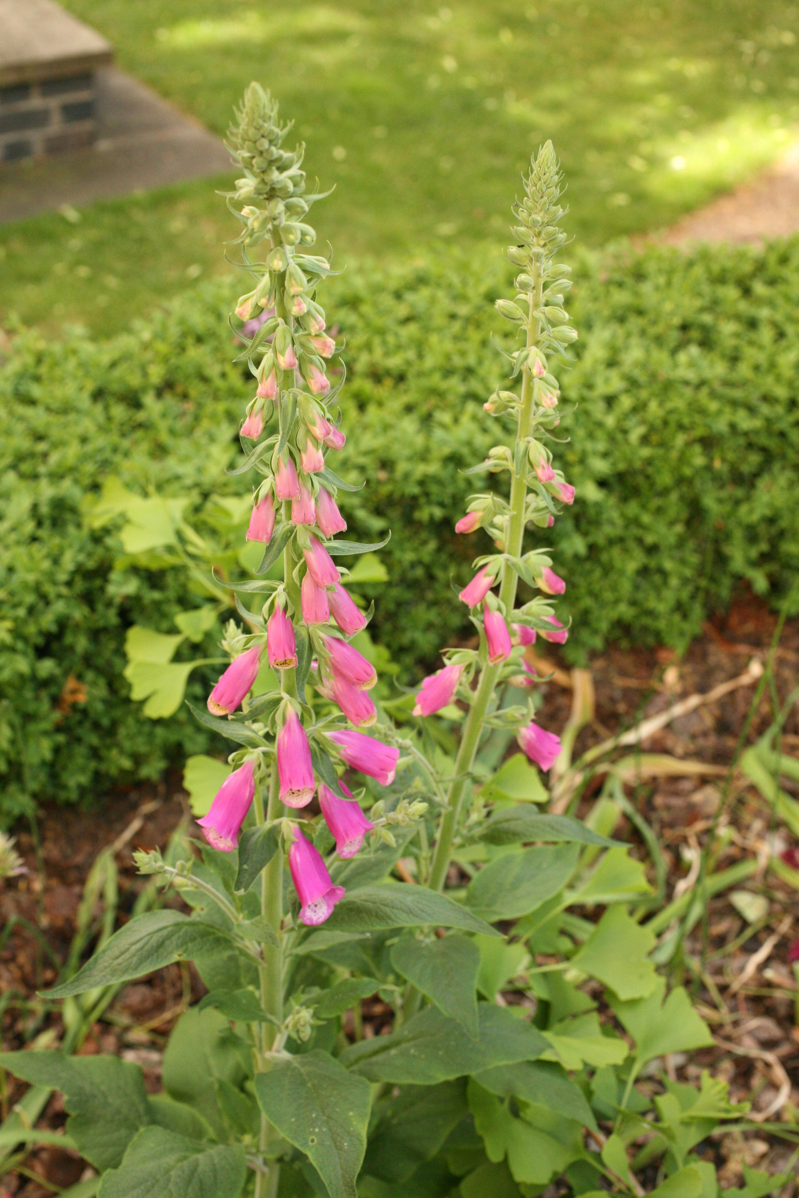

- Until the 1960s digoxin was still extracted from foxglove plants but now it is synthesised. The pure compound is much more consistent and reliable than the previous plant extracts. One advantage of the plant extracts is that they did not frequently cause intoxication because they induced nausea and vomiting within minutes of ingestion, preventing the patient from consuming more.
- Because of the presence of digoxin and digitoxin foxglove plants are very poisonous. Symptoms of Digitalis poisoning include seeing yellow, a low pulse rate, nausea, vomiting, and finally death. Fatal accidents have involved children drinking the water in a vase containing digitalis plants.
- The pollen contains up to 80% digitalis, and this pollen can be found on neighbouring plants stamens when they are in bloom. This effect can cause accidental digitalis exposure if the exposed stamens of other plants are consumed in any way by humans.
Photographs courtesy of Dr H Oakley and Royal College of Physicians, London

